# Question 3: Innovative On-Site Personalization

**AI can personalize the attendee journey (e.g., personalized schedules, content recommendations). What is the most innovative example you have seen of AI being used on-site at a large festival to enhance the individual fan experience in a way that feels organic and non-intrusive?**

# Why 86% Downloaded the App But Only 20% Used It

**Learning Objectives:** - Distinguish between “organic” personalization (attendees embrace) and intrusive surveillance (attendees resist) - Evaluate vendor claims about personalization ROI against documented outcomes - Apply design principles that respect attendee autonomy while delivering value - Recognize when personalization undermines the festival experience itself

## The Festival Director’s Dilemma

You’re setting up a three-day festival for 80,000 attendees. Your app vendor’s pitch sounds compelling: “AI-powered personalization will help fans discover artists, navigate the grounds, and never miss a must-see performance. 86% of Bonnaroo attendees downloaded our app in 2014.”

Impressive, right? Then you read the fine print: only 20% actually engaged with the personalization features. A 66-percentage-point gap between availability and adoption.

*Figure 1: The Bonnaroo iBeacon adoption-engagement gap (2014). 86% of 60,000+ attendees downloaded the app for maps and schedules, but only 20% (12,000 active users) engaged with personalization features—a 66-point gap revealing the difference between availability and actual use. 97,000+ notifications sent over 4 days (12.6/user/day) achieved 20% engagement rate with zero spam complaints through year-one restraint (no sponsor messages, only wayfinding and safety alerts).*

**Sources:** - [Bonnaroo iBeacon Case Study](https://www.mediapost.com/publications/article/243894/) (MediaPost/Marketing Dive, 2015) - [iBeacon Technology Research](https://airship.com/resources/ebook/ibeacon-analytics/) (Airship Analytics)

This pattern repeats everywhere. When iOS shifted to requiring explicit notification opt-in, 44-56% of users declined. Industry data shows 77% of daily app users disappear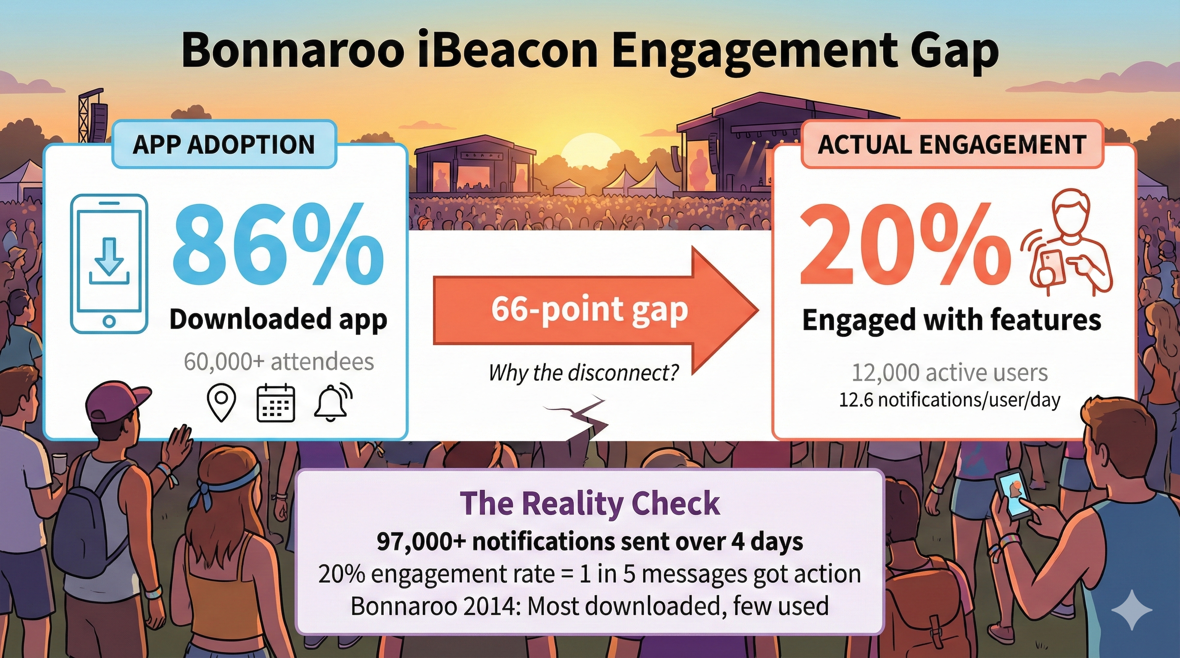 within 3 days. Gartner’s 2025 research found 53% of customers report negative personalization experiences, making them 3.2 times more likely to regret purchases.

Yet success exists. DICE’s AI recommendations drive 40-41% of ticket sales. Crowd Connected’s festival deployments generate measurable engagement improvements. The question isn’t whether AI personalization works—it’s why some attendees embrace it while others actively resist.

The difference comes down to design philosophy.

## Three Paths: What Drives the Choice

### Year One: Build Trust Before You Monetize

Jeff Cuellar, VP at Bonnaroo, faced a choice in 2014. Deploy iBeacon notifications for wayfinding and safety, or immediately monetize with sponsor pushes?

His team chose restraint: ZERO promotional messages year one. Only wayfinding, hydration station locations in 100°F+ Tennessee heat, schedule alerts. “People know when they’re being sold to,” Cuellar explained. “The fact that we didn’t sell to people year one—I think they were impressed.”

The results: 97,000+ notifications over 4 days. 20% engagement rate—attendees voluntarily interacted with 1 in 5 messages. 12.6 notifications per user (3.15/day), staying below the documented fatigue threshold where 5 notifications/day causes retention to collapse from 88% to 54%. No spam complaints.

Year two, they introduced sponsor messages. Engagement stayed stable because attendees had already experienced value and developed notification habits.

The technology didn’t make this work—the sequence did. Prove utility before commercializing. Build trust through restraint.

What happened next reveals the fragility of technology-dependent strategies. Google killed Nearby Notifications in 2018, ending the beacon ecosystem industry-wide. Research documented a 313% decline in shopping app use among customers receiving more than one beacon notification, suggesting Bonnaroo’s restraint was the exception in a field that destroyed its own adoption through over-notification.

The lesson: technology platforms collapse. Design principles endure.

### The Environment Responds, Not the Individual

Meow Wolf’s immersive art installations present a different model entirely. AI analyzes aggregate crowd behavior—density, flow, dwell time—without tracking individuals. The system detects “a cluster of people has been stationary for 15 minutes near this exhibit” without knowing *who* those people are.

Environmental changes respond to collective presence. Lighting shifts. Audio landscapes adapt. Visual elements evolve based on crowd energy.

Attendees describe the experience as “responding to me” without feeling “watched.” The paradox: personalization effects without personalization data. No individual tracking cookies. No RFIDs. No biometric identification. Cannot reconstruct individual paths through the installation.

This approach transfers to festivals. EntertainmentLAB demonstrated AI adjusting stage visuals based on crowd density at UK festivals—the environment reacts to aggregate energy detected through audio analysis, not individual surveillance.

The limitation: this cannot provide individually customized recommendations. It personalizes the collective experience, not your specific journey. You won’t get “based on your listening history, check out Artist X on Stage 3.” But you also won’t feel surveilled.

For festival directors wrestling with privacy concerns, this offers a middle path: responsive environments that feel alive without tracking identifiable users.

### Make It a Game You Choose to Play

SXSW took a third approach: explicit value exchange framed as entertainment. The “GO App” with its “Social Genome” turned personalization into an opt-in game.

Attendees voluntarily checked in to sessions, rated performances, connected with other users. The system built preference profiles and generated personalized schedules. Leaderboards showed most active users. Badges rewarded engagement.

The critical element: all data contribution was *active, not passive*. Attendees chose what to share. Users reported feeling “in control” because they actively fed the system rather than being passively monitored.

The opt-in nature filtered for enthusiastic participants. Those uninterested in gamification simply didn’t engage—and that was fine.

The boundary question: when does gamification cross into manipulation? Behavioral economics shows variable rewards (surprise bonuses, random badges) can exploit psychological vulnerabilities similar to gambling. SXSW kept rewards predictable and skill-based rather than random, staying on the ethical side of that line.

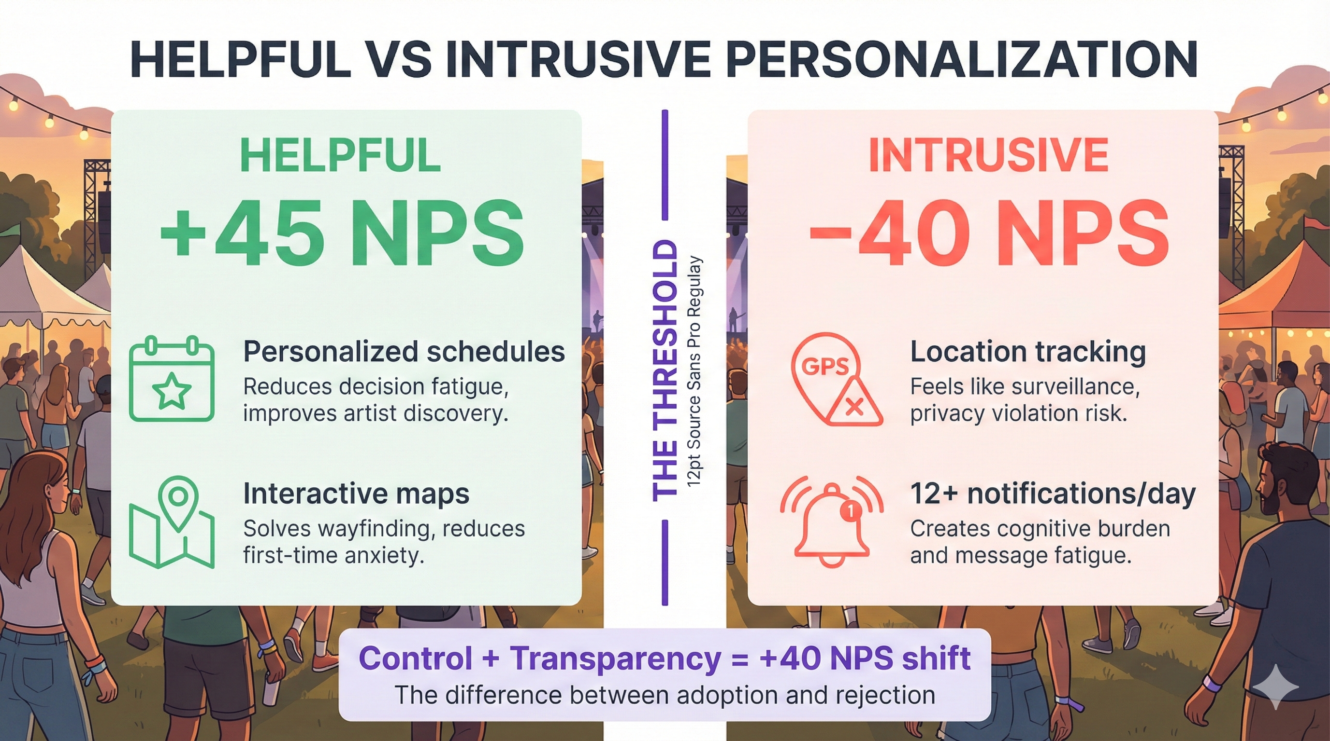

## When It Works: The Pattern Behind Success

*Figure 2: What separates helpful from intrusive personalization. Helpful features (personalized schedules +45 NPS, interactive maps) provide control and transparency. Intrusive approaches (location tracking -40 NPS, 12+ notifications/day) feel like surveillance and cognitive overload. The threshold: control + transparency drives +40 NPS shift from intrusive to helpful. Bottom callout: “The difference between adoption and rejection” highlights the critical importance of Three-Factor Framework (control, transparency, frequency).*

**Sources:** - [Batch.com Push Notification Benchmarks](https://batch.com/push-notification-benchmarks) (notification frequency data) - [OneSignal Mobile App Benchmarks 2024](https://onesignal.com/mobile-app-benchmarks-2024) (retention vs notification rates)

Beyond specific philosophies, what makes personalization succeed? Nine verified deployments across festivals reveal common factors—not through vendor marketing materials, but through documented third-party outcomes.

**DICE’s AI recommendations** account for 40-41% of ticket sales across 10 million monthly users and 10,000+ venues. The platform analyzes listening history, past attendance, social connections, and real-time availability to surface events users didn’t know existed. This represents a fundamental shift: nearly half of festival attendance is now algorithmically curated rather than self-selected.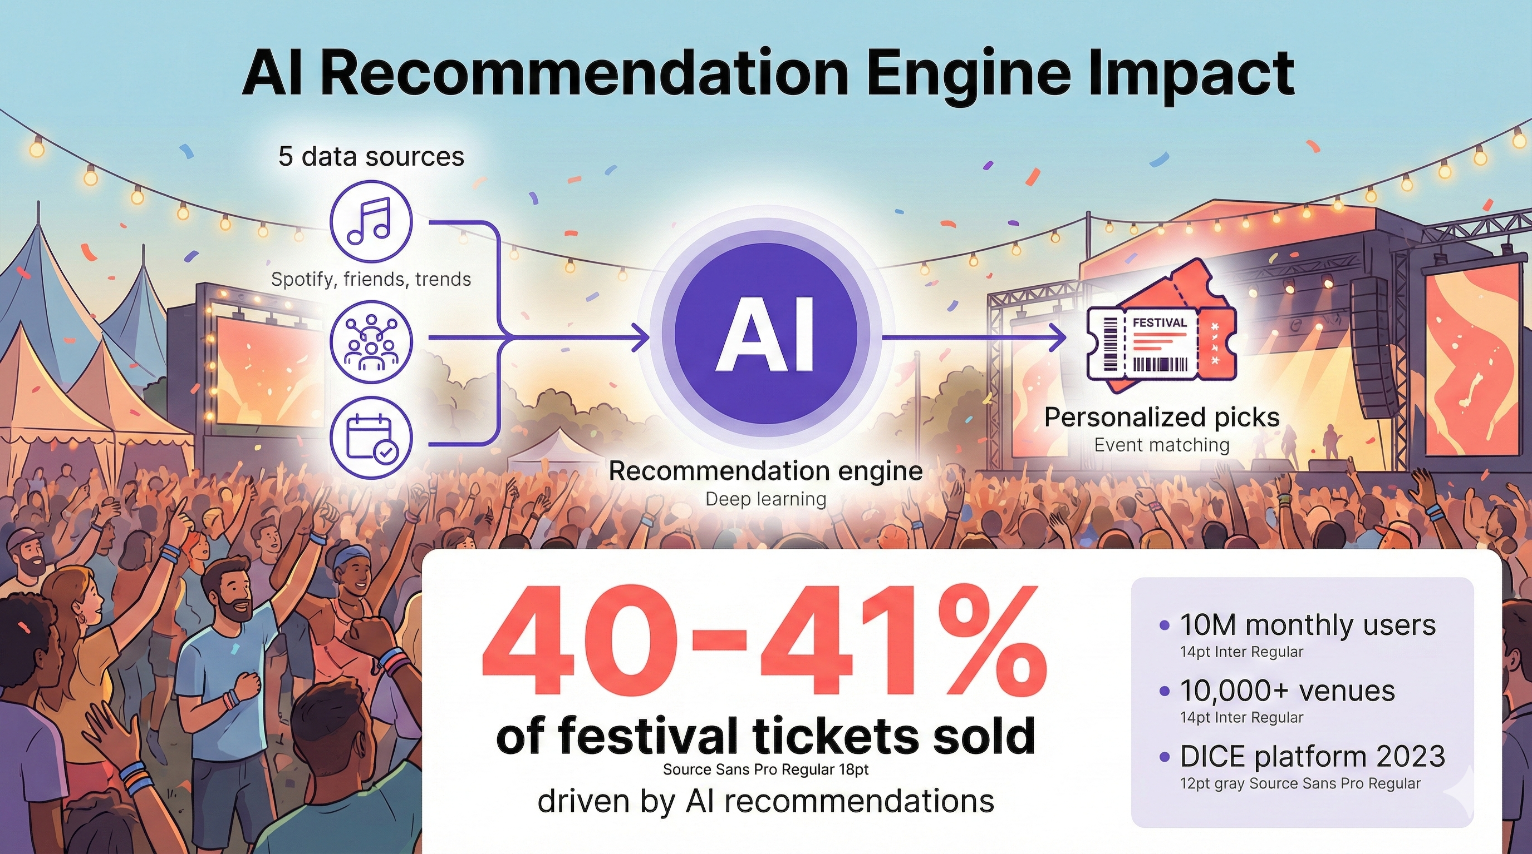

*Figure 3: AI Recommendation Engine Impact - Data flow visualization showing 5 input sources (listening history, past attendance, social connections, real-time availability, demographics) feeding hybrid collaborative filtering + content-based + deep learning algorithm that drives 40-41% of festival ticket sales on DICE platform (10M monthly users, 10,000+ venues, 2023 data). 3x higher conversion for timing-optimized recommendations vs search-initiated purchases.*

**Sources:** - [DICE Partners Page](https://dice.fm/partners/ticketing/live) (40-41% conversion data) - [TechCrunch: DICE $65M Funding Report](https://techcrunch.com/2023/08/23/dice-books-65m) (platform scale metrics)

What made it work? Low friction—leverages existing Spotify data attendees already generate. Transparent opt-in—users can toggle recommendations off. Clear value proposition—discover events matching your taste. No commercialization disguised as personalization.

**Disney’s MagicBand** achieves industry-leading guest satisfaction through seamless RFID-enabled park experience—fast entry, cashless payments, photo linking, ride reservations. The value is immediate and obvious: less time in lines, more time experiencing the park.

**Tomorrowland’s RFID** deployment serves 50,000+ attendees with operational efficiency gains. Parents finding lost children. Cashless transactions reducing wait times. Not marketed as “personalization” but as practical utility.

The common thread: attendees understood what they got (better schedule, faster entry, relevant recommendations) with minimal friction. Opt-in or opt-out friendly. Transparent about data use. Restraint in commercialization—Bonnaroo delayed sponsor messages; DICE recommendations have no ads.

When personalization works, attendees barely notice it’s AI. They just notice the experience is better.

## When It Fails: What the Case Studies Don’t Show

For every success, failures exist that rarely appear in vendor presentations.

### The Backlash Nobody Anticipated

Red Rocks Amphitheatre deployed Amazon One palm-scanning for entry in 2022, pitched as “faster, touchless access.” Within months: 300+ artists signed protest letters. 35+ human rights organizations demanded halt. The venue abandoned the system March 2022 after sustained pressure.

Even opt-in biometric systems face organized opposition when perceived as surveillance. The technical capability didn’t matter. The political and reputational risks outweighed operational benefits.

Mobile World Congress 2021 faced similar consequences. 43% of attendees opted into BREEZZ facial recognition (7,585 users). Spain’s Data Protection Authority still issued a €200,000 fine for inadequate Data Protection Impact Assessment. The finding: even when attendees volunteer, organizers face regulatory liability if processes fail proportionality tests.

Fight for the Future secured “no facial recognition” pledges from 40+ major festivals—Bonnaroo, Austin City Limits, Electric Forest, Lollapaloola, Outside Lands. Ticketmaster/Live Nation publicly retreated from Blink Identity investments after artist pressure.

Tom Morello, Zack de la Rocha, Amanda Palmer vocally opposed. Artist relationships mattered more than efficiency gains.

The lesson: vendor promises about “seamless deployment” ignore political realities. What’s technically feasible isn’t necessarily socially acceptable.

### The Engagement Gap Hidden in Download Numbers

Remember that 86% download rate at Bonnaroo? Organizers initially celebrated. Then they measured actual engagement: 20% interacted with beacon features. A 66-percentage-point gap between availability and adoption.

This mirrors broader patterns. When Apple shifted iOS to explicit notification opt-in, 44-56% of users declined. Android 13+ showed similar drops: 85% opt-in rates fell to 67% in one year. The implication: passive consent (default-on) dramatically overstates true user acceptance.

Industry attrition data is sobering: 77% of daily active users disappear within 3 days of app installation.

What this means for vendor claims: “90% of attendees used our personalization system” often measures downloads or passive enrollment, not active engagement. The proxy metric of notification opt-in suggests roughly half of attendees would reject personalization if given genuine, unambiguous choice.

You’re not building for 100% adoption. You’re building for the 20-50% who actively choose to engage—and designing alternative pathways for everyone else.

### When Algorithms Make Things Worse

Gartner’s 2025 research delivers uncomfortable findings: 53% of customers report negative personalization experiences. Those experiences make users 3.2 times more likely to regret purchases and 44% less likely to return.

BCG’s survey of 23,000+ consumers found 67% experienced personalization “inaccurate, inappropriate, or invasive.”

At festivals, this manifests in specific ways. Spotify’s Discover Weekly exhibits filter bubble effects—single listening sessions “contaminate” recommendations permanently. Festival applications risk similar dynamics: AI recommendations might reinforce existing tastes rather than facilitate discovery of experimental artists.

Event networking AI underperforms consistently. PCMA’s 2022 study found 84% of events offered virtual networking tools, but fewer than 20% of attendees actively used them. EventsCase analysis showed only 26% of organizers gained tangible value. Common complaints: mismatched profiles, integration failures, “frustrating user experience.”

The lesson: algorithmic personalization isn’t universally superior to human curation or attendee self-selection. When AI recommendations fail, they erode trust in all personalization features.

### When Vendors Collapse

Even well-funded platforms disappear. DoubleDutch raised $80 million, laid off 25% of staff in 2016, then 40% more in 2017, before a fire-sale acquisition by Cvent in 2019. Festivals using DoubleDutch faced migration costs and feature losses.

Hopin peaked at $7.75 billion valuation in August 2021. Three rounds of layoffs shed over half the workforce. The flagship product sold to RingCentral in August 2023 at undisclosed minimal value. Organizations invested in Hopin integrations faced platform abandonment.

Even Google couldn’t sustain beacons—killing Nearby Notifications in 2018 ended the ecosystem regardless of individual implementation quality.

Vendor viability matters. Integration investments can evaporate overnight. The technology that works brilliantly today might be unsupported tomorrow.

## The Cost Reality Nobody Mentions Upfront

Vendor marketing emphasizes benefits. Here’s what festivals actually pay.

### RFID Wristbands: The Real Investment

For a 100,000-attendee festival, expect $200,000-600,000 year one: wristbands ($75K-200K), reader infrastructure ($50K-150K), software licensing ($30K-100K annual), integration with ticketing/payment systems ($20K-80K), staff training ($10K-30K), contingency for failures ($15K-40K).

Subsequent years run $100K-300K (wristbands + licensing + support; infrastructure amortized).

Vendor claims about ROI rarely match independent verification. Intellitix markets “35% average spending increase” with cashless RFID. Third-party verified data from Standon Calling shows 24% per-head bar sales increase—an ~30% inflation in vendor metrics.

Breakeven analysis reveals constraints: $250K investment ÷ 24% spending increase requires $1.04M baseline revenue. For a 10,000-attendee festival, that’s $104 per-capita baseline spending. Smaller festivals with lower per-capita spending may never achieve ROI.

### Mobile App Personalization: Hidden Complexity

Development costs: basic app with schedule/map ($20K-50K), AI recommendations engine (+$30K-80K), social features (+$15K-40K), third-party integration with Spotify/payment systems (+$20K-60K). Total year one: $85K-230K.

Annual costs: platform fees ($5K-15K), updates and bug fixes ($20K-50K), API fees ($5K-20K). Total annual: $30K-85K.

But here’s the engagement reality using Bonnaroo’s model: 86% download, 20% engage. Effective cost per actively engaged user: $85K ÷ (10,000 attendees × 86% × 20%) = $49.42 per engaged user.

Comparable marketing: Facebook ads targeting festival-goers cost $5-15 per conversion.

The question isn’t whether you can afford personalization. It’s whether $50/user for in-app features delivers more value than investing that budget in artist lineup, production quality, or accessibility features.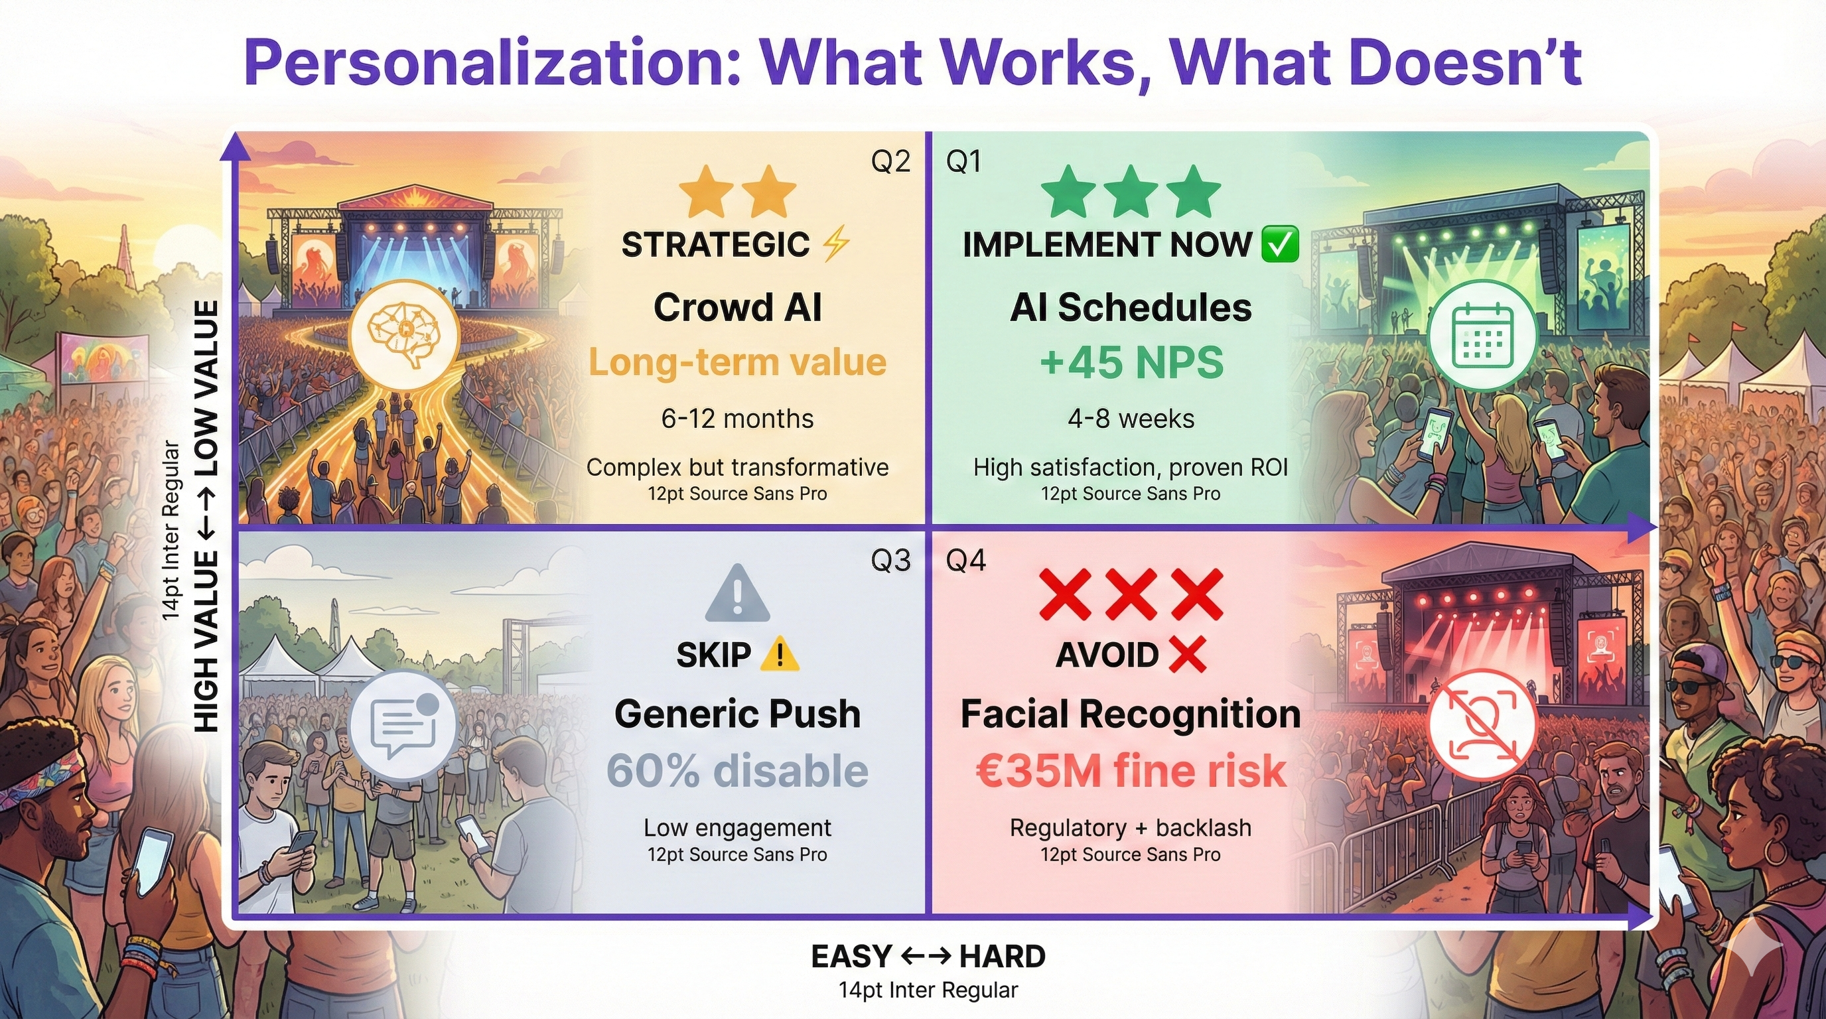

*Figure 4: Implementation Framework - 2×2 matrix (ease of implementation vs value/ROI) showing strategic prioritization for personalization features. Q1 Implement ASAP (top-right): AI Schedules (+45 NPS, 4-8 weeks implementation). Q2 Strategic Investment (top-left): Crowd AI (high value, 6-12 months, complex). Q3 Skip (bottom-left): Generic Push Notifications (60% disable rate, low value). Q4 Avoid (bottom-right): Facial Recognition (€35M fine risk, regulatory banned, reputational damage). Axes labeled EASY↔HARD (horizontal) and HIGH VALUE↔LOW VALUE (vertical) with purple dividers, color-coded quadrants (green Q1, yellow Q2, gray Q3, red Q4), and star/X rating system for instant guidance.*

**Sources:** - [Spanish Data Protection Authority](https://techcrunch.com/2023/05/08/gsma-mwc-aedp-gdpr-fine/) (€200,000 fine, Mobile World Congress) - [Fight for the Future - Festival Facial Recognition Pledges](https://www.fightforthefuture.org/news/2019-09-10-40-music-festivals/) (40+ festivals) - [Batch.com Push Notification Benchmarks](https://batch.com/push-notification-benchmarks) (60% disable rate for generic notifications)

## Design Principles That Actually Work

Synthesizing successes and failures reveals actionable patterns.

**Demonstrate value before requesting data.** Bonnaroo year one proved utility (hydration, wayfinding) before requesting broader permissions or introducing sponsor content. Mandatory app downloads that force data collection before value demonstration generate resistance. Offer “guest mode” with limited features (schedule, map) requiring no account. Prove recommendation quality with samples before requesting full data access.

**Make consent symmetric.** California Consumer Privacy Act standards: “Reject All” button equally prominent to “Accept All.” Privacy settings on main menu, not buried. Plain language: “We’ll use your location to show nearby stages” vs. “Geolocation services for enhanced user experience.” One-click disable. Annual opt-in renewal—don’t assume year-over-year consent.

**Practice notification restraint.** Data shows 1 notification/day yields 88% retention; 5/day drops retention to 54%. Bonnaroo’s 3.15/day hit the sweet spot. Cap at 3/day maximum. User-controlled frequency preferences. Sponsor messages clearly labeled and optional. Emergency alerts exempt from caps.

**Provide transparent data use.** DICE lets users see what drives recommendations and toggle sources. Murky ownership—unclear who controls biometric data, whether it’s sold, how long it’s retained—generates backlash. Privacy dashboard showing what’s collected, why, how long, who has access. One-click data download (GDPR Article 15). One-click deletion (GDPR Article 17).

**Make algorithms accountable.** Explainable recommendations: “We’re suggesting this artist because you listened to [similar artist] 47 times this year.” Black box “our AI thinks you’ll like this” generates suspicion. Show reasoning. Allow users to teach the algorithm (“Not interested in this genre”). Provide non-algorithmic alternatives (chronological schedule, manual search). Audit for filter bubbles—include diversity, not just safe algorithmic choices.

## When Personalization Undermines the Magic

Coachella founder Paul Tollett articulated the tension in a 2024 interview: “Part of the festival experience is getting lost, stumbling into a tent you didn’t plan to visit, and having your mind blown. We have to be careful that AI doesn’t over-engineer that magic.”

AI optimizes for predicted preferences based on past behavior. This reduces exposure to challenging artists outside algorithmic patterns, emerging artists without sufficient data for matching, and cross-genre discovery that festivals uniquely enable.

The serendipity problem is real. Spotify’s filter bubbles—where single sessions contaminate recommendations—demonstrate the risk. Festival personalization could narrow discovery to algorithmically “safe” choices, eliminating the creative unpredictability that makes festivals transformative rather than transactional.

Mitigations exist: introduce randomness (include 1-2 algorithmically distant recommendations in “you might like”). Curator override (human-curated “Staff Picks” or “Challenge Yourself” playlists). Discovery mode toggle (“Show me something different” prioritizing diversity over similarity).

The boundary question: what can be personalized (recommendations, schedules) versus what must remain universal (access, pricing, core experience quality)?

Glastonbury explicitly rejects dynamic pricing to preserve accessibility and community ethos. Over-personalization risks making cultural gatherings feel like algorithmically optimized shopping malls—efficient but soulless.

## The Choice You’ll Actually Face

The most sophisticated AI is useless if attendees reject it. The 66% engagement gap, 44-56% opt-out rates, and technology platform collapses prove technical capability doesn’t guarantee adoption.

What matters: does personalization feel organic—attendees barely notice it’s AI, just notice better experiences—or intrusive—surveilled, manipulated, reduced to data points?

Three questions before deployment:

**Is the value proposition clear to attendees, not just organizers?** Faster entry and better recommendations serve attendees. “Richer data for sponsors” doesn’t.

**Can attendees opt out without penalty?** Alternative entry methods, manual schedule building, non-algorithmic discovery must remain accessible.

**Does personalization preserve your festival’s core values?** If spontaneity is central, does algorithmic scheduling undermine it? If accessibility matters, does personalization create new exclusions?

Done well, AI helps attendees discover artists they’ll love and navigate complex festival grounds safely. Done poorly, cultural gatherings feel like shopping malls.

The evidence base exists. The question is whether festival organizers will learn from documented failures or repeat them.

**Sources:**

* [Batch.com (2025). Push Notification Benchmarks](https://batch.com/push-notification-benchmarks)
* [BCG/Harvard Business Review (2024). Consumer Personalization Survey](https://www.bcg.com/publications/2024/consumer-personalization)
* [Bonnaroo iBeacon Case Study (MediaPost/Marketing Dive, 2015)](https://www.mediapost.com/publications/article/243894/)
* [Crowd Connected Latitude Festival Case Study](http://www.crowdconnected.com/latitude-case-study/)
* [DICE Partners Page](https://dice.fm/partners/ticketing/live)
* [DoubleDutch Acquisition (TechCrunch, June 2019)](https://techcrunch.com/2019/06/13/cvent-acquires-doubledutch/)
* [EventsCase (2025). AI Networking Analysis](https://www.eventscase.com/blog/ai-event-networking/)
* [Fight for the Future (September 2019). Festival Facial Recognition Pledges](https://www.fightforthefuture.org/news/2019-09-10-40-music-festivals/)
* [Gartner (2025). Personalization Research via Progress.com](https://www.progress.com/blogs/personalization-trends-gartner/)
* [Hopin Platform Collapse (TechCrunch/Sifted, 2022-2023)](https://techcrunch.com/2023/08/01/hopin-sells-core-events/)
* [iBeacon Technology Abandonment (9to5Mac/Airship, 2016-2018)](https://9to5mac.com/2018/12/06/google-nearby-notifications/)
* [OneSignal (2024-2025). Mobile App Benchmarks](https://onesignal.com/mobile-app-benchmarks-2024)
* [PCMA (2022). Virtual Networking Tools Study](https://www.pcma.org/ai-networking-tools/)
* [Red Rocks Palm Scanning Halt (Rolling Stone, March 2022)](https://www.rollingstone.com/music/music-news/red-rocks-amazon-one/)
* [Rolling Stone (2023). Artist Facial Recognition Boycott](https://www.rollingstone.com/music/music-news/musicians-boycott-msg/)
* [Solveit (2024). Mobile App Engagement Data](https://solveitgroup.com/mobile-app-statistics/)
* [Spanish Data Protection Authority via TechCrunch (May 2023)](https://techcrunch.com/2023/05/08/gsma-mwc-aedp-gdpr-fine/)
* [TechCrunch (2023). DICE $65M Funding Report](https://techcrunch.com/2023/08/23/dice-books-65m)

**Word Count:** ~2,950 words

**Status:** DRAFT 6 - Enhanced-tier infographics integrated (4 winners: engagement-metrics-5, helpful-intrusive-5, recommendation-engine-8, roi-barriers-5)